SUMMARY REPORT

EXCHANGE TRIP IN GHANA 2022/2023
BETWEEN AFI (AFRICAN FOOTPRINT INTERNATIONAL, ROYAL ACADEMY OF MUSIC AARHUS AND UNIVERSITY OF CAPE COAST – (DEPARTMENT OF MUSIC)

The Exchange/study trip was hosted by African Footprint International.

The program had Different Workshops including drumming, dancing, singing, band playing, history and other lectures as part of the content prepared for the trip and was focused on exchanging cultures through the learning together.

The students came in batches arriving first in Accra -Ghana from the 26th of December 2022 and onward. They were welcomed by the management team of African footprint international.

The total number of participants were 14 students and 3 teachers.

ORIENTATION
On the 27th December 2022, the management team making up of some members and teachers of AFI and a representative from The University of Cape coast -UCC department of Music and the CEO of African Footprint International and the board chairman of African Footprint Foundation Denmark were all present.

The project started with orientation. Welcoming the participants to Ghana and informing them about the town and the project in question.

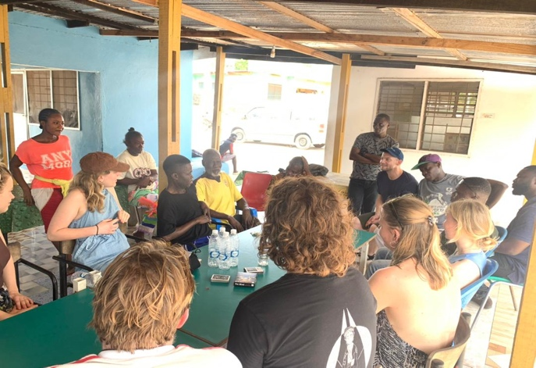 | 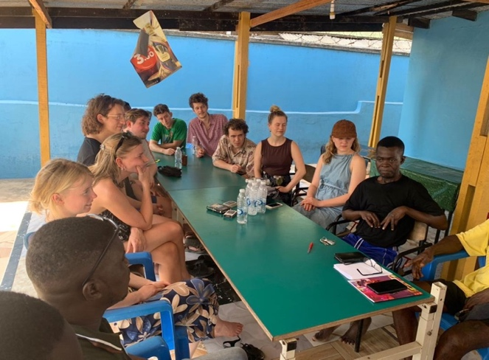
Briefing – Orientation | Orientation

WORKSHOP
On the 28th December 2022 the project started with workshops.
The trip was very intense as the day starts at 06.00 a.m. and ends at 19.00 p.m.

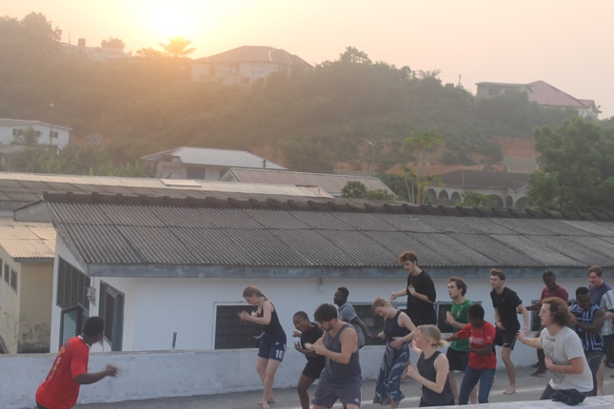 | 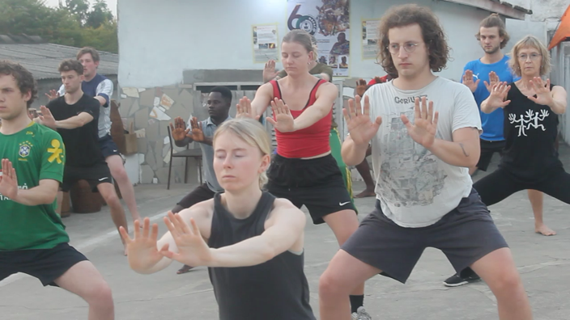
Morning wake up training with sunrise | Morning wake up stretch
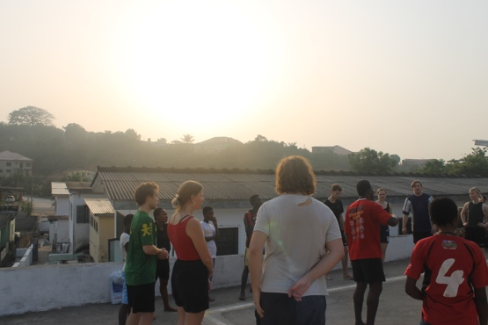 | 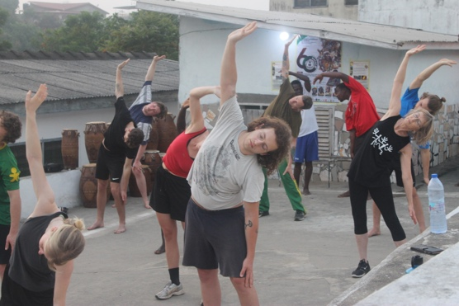
Morning wake up training with sunrise | Morning wake up stretch

EARLY MORNING WARM UP (AEROBIC)
The early morning exercise, stretching and keeping fit which forms part of exercise for keeping the body healthy. This exercise was proceeded by basic rhythmic
moves to drumming and dancing which we call the dance techniques.

DANCE WORKSHOPS
The dance workshop started after early morning stretching and movement.
The students were taken through dance and movements.

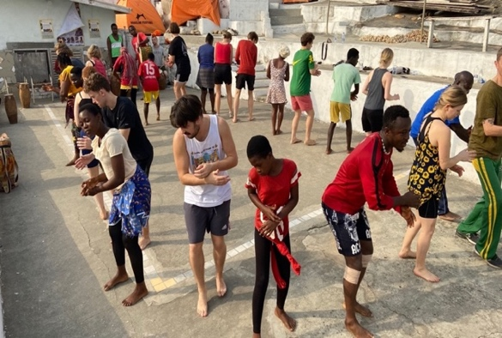 | 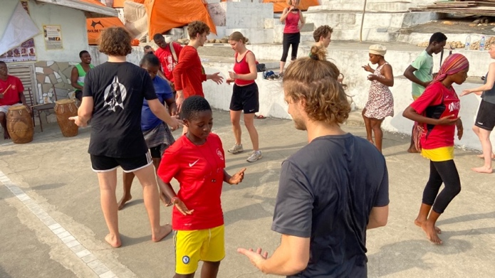
Dance Workshop | Dance workshop
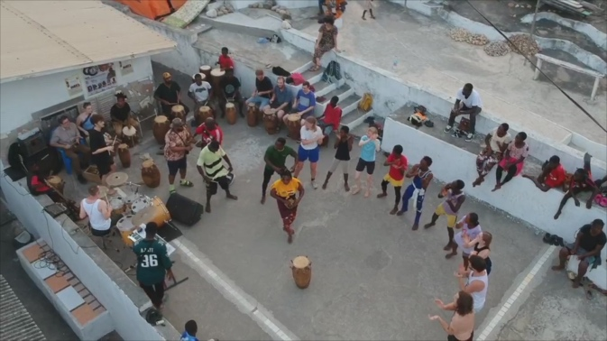 | 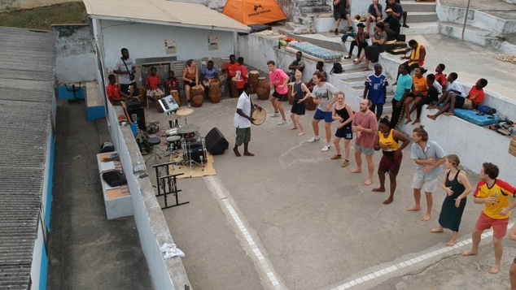
The second face of the day training time | Training time

DRUMMING WORKSHOPS
After the dance lessons follows the African traditional drumming class. The drum patterns to the dance learned in the morning is taught to the students after the dance lessons.
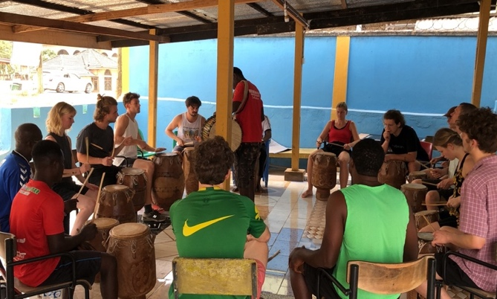 | 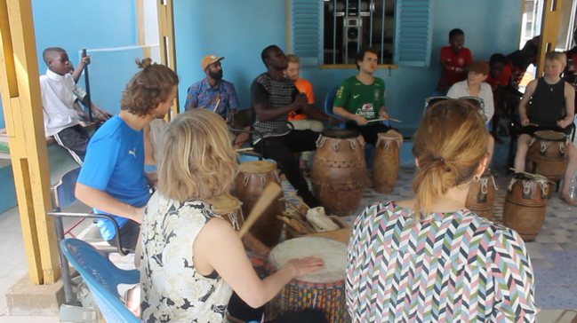
Drumming workshop led by Peter Kofi Bruce | Drum workshop
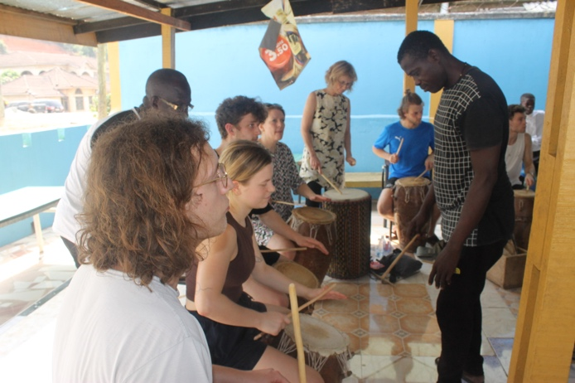 | 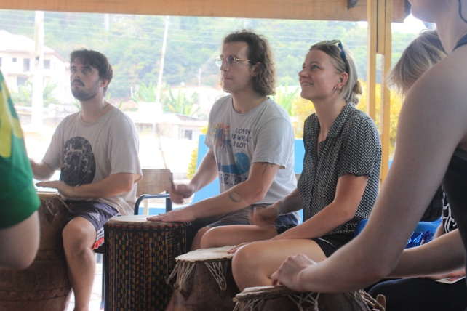
Drumming workshop led by Peter Kofi Bruce | Drumming

SINGING, HISTORY, RESEARCH, LECTURES ETC
This class and hours are used to teach the students about the background, history, findings, research works, Music etc and all the relevant teachings to the student on a particular subject.

There were special lectures like the renowned Ghanaian Divine master drummer - Odomankoma Kyerema Kwemena Pra, Santrofie Band, Professor Eric Otchere, Dr. Regnald Reggie Sackey and others.

Odomankoma Kyerema Kwemena Pra, The renowned Ghanaian Divine master drummer
took them through the type of drums and the origin of the name of the drums and the purpose of each drum as part of Ghanaian culture and history.

Dr. Regnald Reggie Sackey taught and explained the use of calabash in Ghanaian music. He gave the history and explained research findings on some of the dances and the subjects of the day.

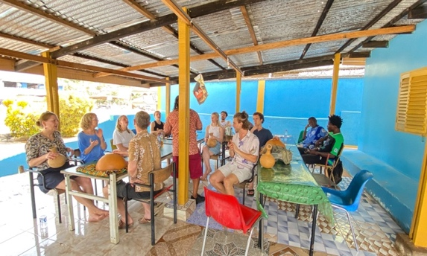 | 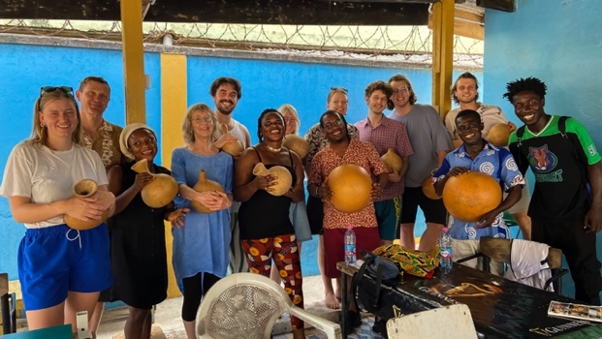
Working on Calabash music | End of Dr Reginald Sackey’s class

Professor Eric Otchere, as part of the workshop lectures organized at the University of Cape Coast, Department of Music and Dance a researched project into the way of the traditional fishermen and their original music while at work to our time . This he taught and lectured on the big research of music and its roots that he has documented.

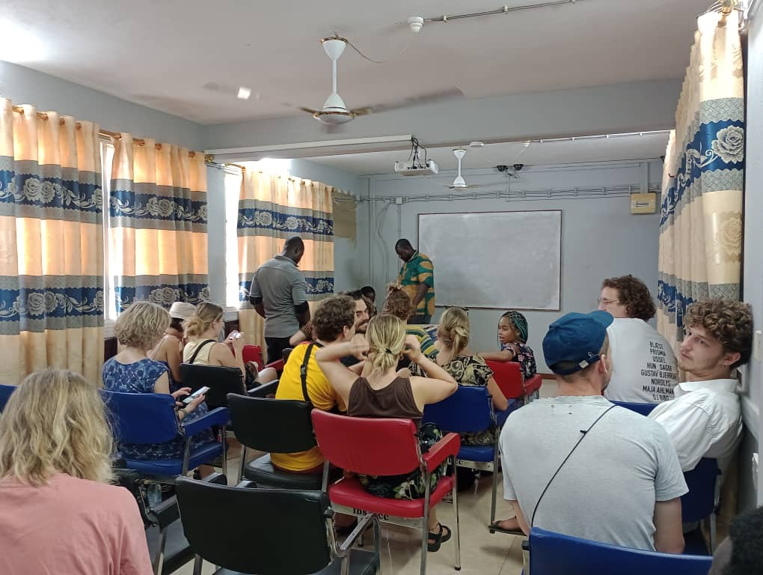 | 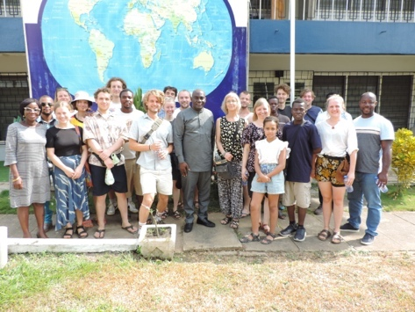
Prof Eric Otchere giving lectures | At the University of Cape Coast
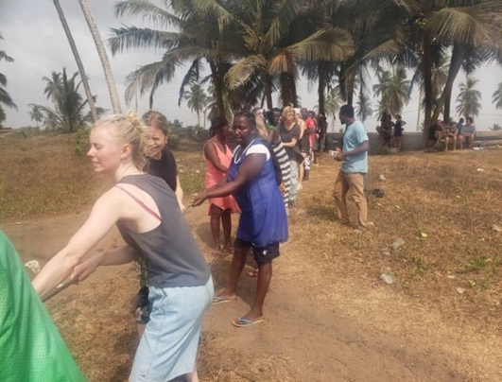 | 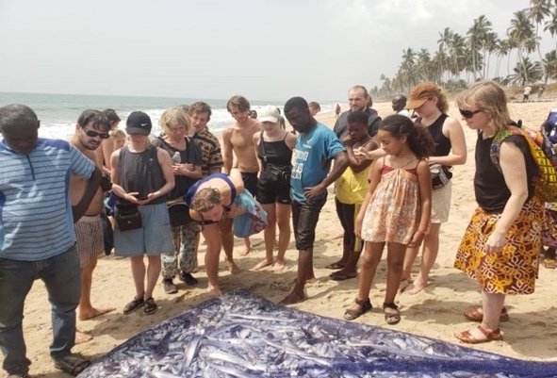
Fishermen pulling their nets with music | After the pulling of the nets comes fish

HIGHLIFE LESSON
Ghana - as part of our musical influence, were known by our genre of music which was first used to identify us, as people from Ghana. Highlife is a peculiar rhythm and a genre of music known to be played mostly in Ghana.

On the final day, the 13th January 2023, one of the Ghanaian finest and biggest musical band
Called SANTROFIE BAND lead by EMMANUEL OFORI AND DOMINIC took the student through the various rhythms that makes up the highlife and allowed the student to play after they were taught.

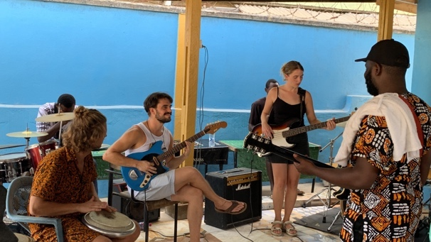 | 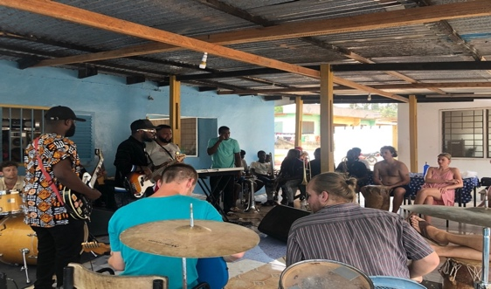
Highlife music class by Santrofie Band | Highlife music class by Santrofie Band

AFTERNOON DANCE REHEARSHAL – ENSEMBLE DANCE TRAINING
Every day in the afternoon in the hours of 4:00pm GMT, there is a music and dance rehearsal with the students, the AFI dancers and the deaf dancers. They go through series of traditional cultural dance moves and other teachings related to drumming and dancing.

This section basically starts with body exercises led by the Footprint members and after followed with the dance for the day. Generally this time of training is Footprints training time designed in a way that students and visitors can feel the speed and the locals way of training on the drumming and dances that they are also working on.
All members from Footprint together with the RAMA students and the deaf dance group come together to learn as one group.

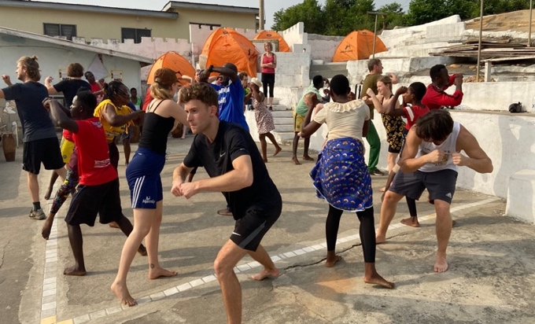 | 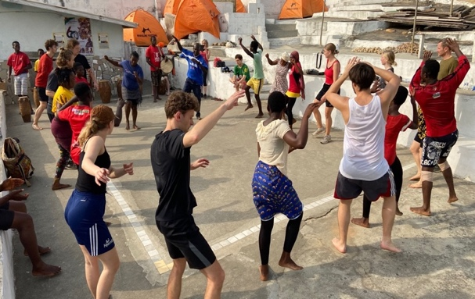
Ensemble Training | Deaf and Hearing members of AFI + RAMA

SIGHT SEEING

TOUR OF CAPE COAST TOWNSHIP
Cape Coast is a historical city with forts and castles built during the slave trade times. It is a place to visit therefore all students were taken to Cape Coast Castle for a guided tour. They also got the chance to see and explore the Cape Coast town.

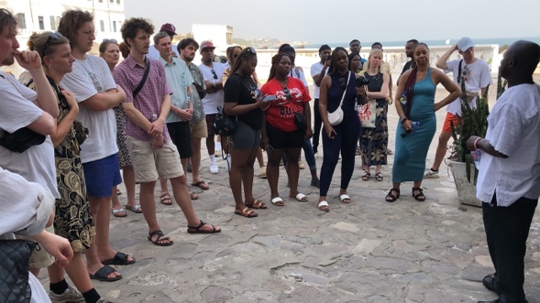 | 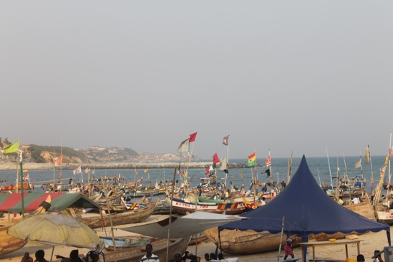
At the Cape Coast Castle – Tour | Cape Coast
TOUR TO KAKUM NATIONAL PARK
On the 31st December 2022, some of the Footprint team and the student of RAMA embarked on a tour to the Ghana’s famous rain forest and canopy walk way at KAKUM NATIONAL PARK. The students were taken through the history, Safari walk through the forest and also the Canopy walk way.

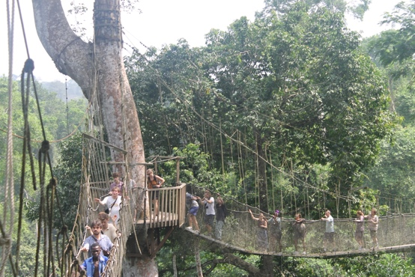 | 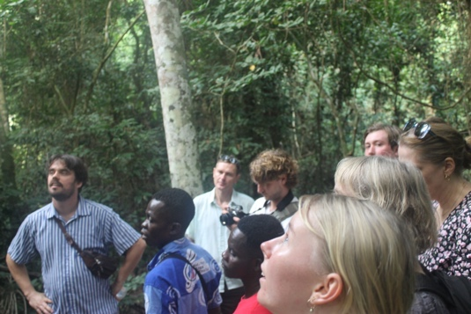
Kakum National Park – Canopy Walk Way | Kakum – Safari walk tour

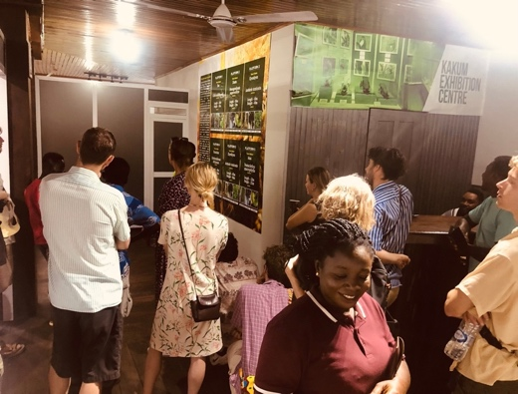 | 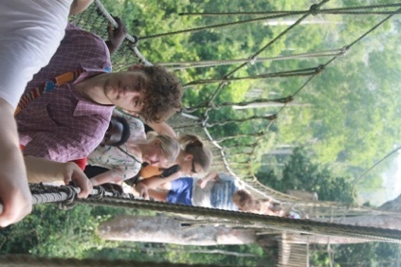
At the Kakum National Park - Tour | Canopy Walk way – Kakum National Park
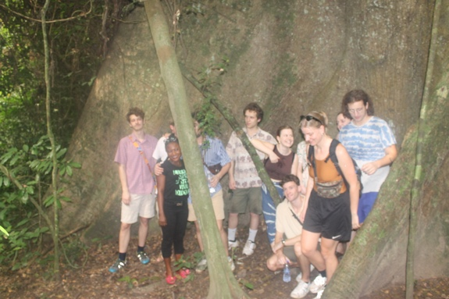 | 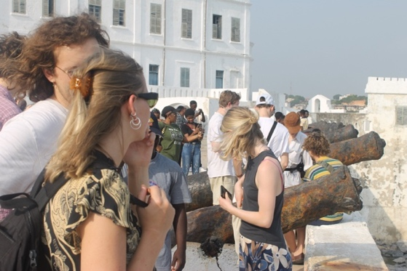
Kakum National Park - The biggest tree | At the Cape Coast Castle – guided tour

OTHER ACTIVITIES

WATCH NIGHT SERVICE – 31 DECEMBER
Every 31st December is called Watch Night. Almost half of the population spend the time in
Church. It is becoming a tradition for people to enter the coming year with God’s blessings. Ghana is a country with 70% of its citizens as Christians and this is gradually becoming an old time practice.

Some of the team from RAMA and Footprint including the CEO SAMUEL KWEKU ADDISON was part who embarked on the visit to one of the profound churches in cape coast called Victory Bible Church.

RADIO AND TV SHOW
On the 6th January 2023, after a wonderful lecture by ODOMANKOMA KYEREMA KWEMENA PRA, the student from RAMA together with AFI visited a radio and tv station called ASASE RADIO. They sung Ghanaian and Danish songs to over 20 thousand listeners live on radio and over 15k viewer on facebook live.

Lena Gregesen – A professor from the Royal Academy - Aarhus took her time to talk about the excitement and opportunity of coming to Ghana, she went further to talk about the vision and the purpose of the exchange program with AFI RAMA and UCC.

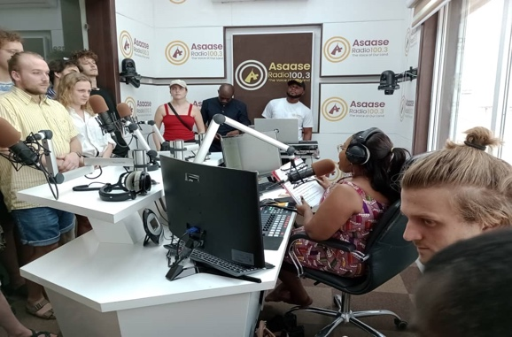 | 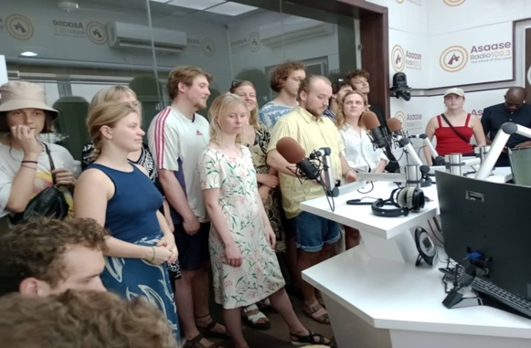
At the radio and TV station | At the Asase Radio LIVE broadcast
 | 
CLICK TO PLAY | CLICK TO PLAY THE VIDEO

WEEKEND RELAXATION
As the saying goes, ALL WORK AND NO PLAY MAKE JACK A DULL BOY, weekend is a relaxing day for all the instructors and students.

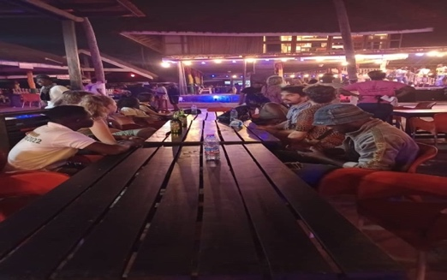 | 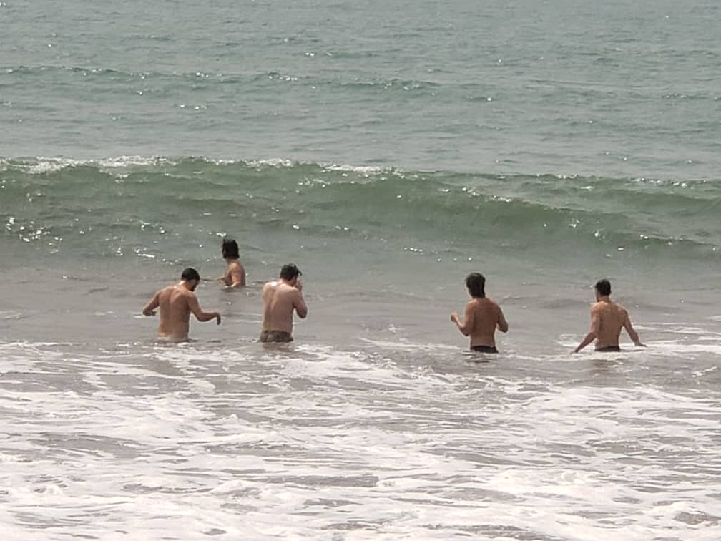
Weekend time - Free | At the beach – Atlantic ocean

TOUR AT UCC -UNIVERSITY OF CAPE COAST
on the 9th January 2023, the student, instructors and the administration of AFI including the CEO of AFI joined the team led by Prof Eric Otchere toured and visited the Music Department of University Of Cape Coast

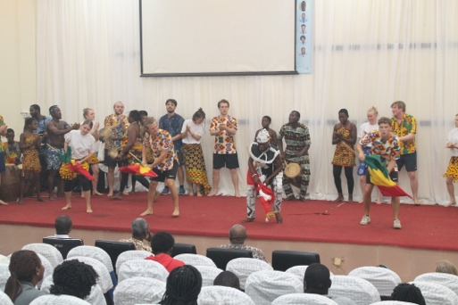 | 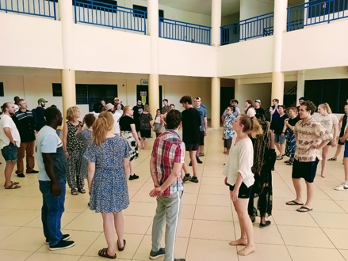
Performance - University of Cape Coast | At the University of Cape Coast - Workshop
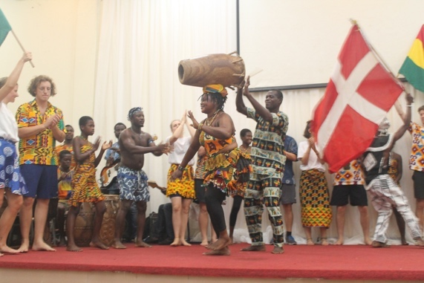 | 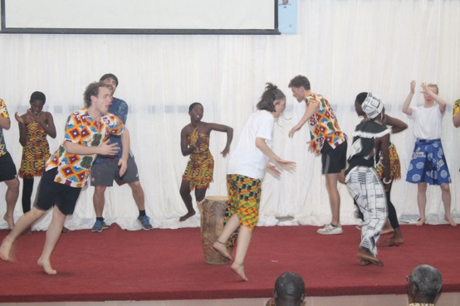
Performance at the University | Performance at the University

END COURSE PERFORMANCE / JOINT CONCERT
On 10th January, there was a concert dubbed AFI + RAMA NIGHT, this concert was to showcase the hard work and the effort of the students during their stay and training. It showcased their ability and hard work put into the learning of the traditional Ghanaian drumming, singing and dancing.

They exhibited that which they have learned during their stay :- singing of the Ghanaian traditional songs, drumming and dancing and also the creation of their rhythm and dance fused with Ghanaian traditional drumming, dancing and singing.

There were Cape Coasters who came to the Addison square gardens to witness the student of Royal Academy of Music Aarhus as they displayed to the Ghanaian community what they have learnt, the program was graced by one of the royalty of the land, a QUEEN MOTHER

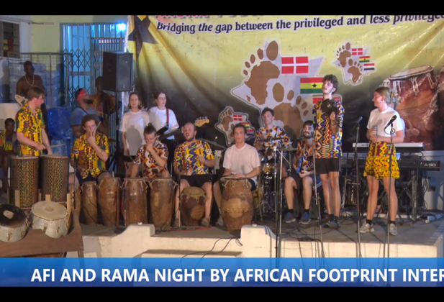 | 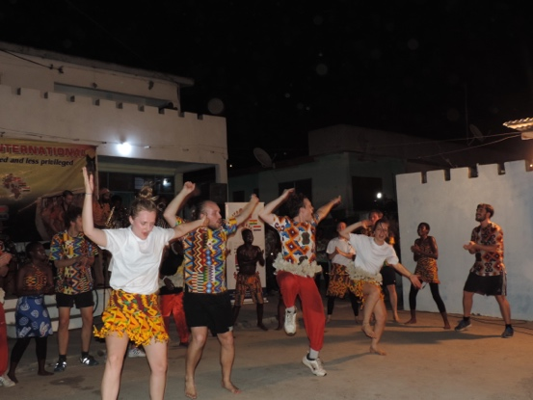
The final presentation of learned activities | Final Performance
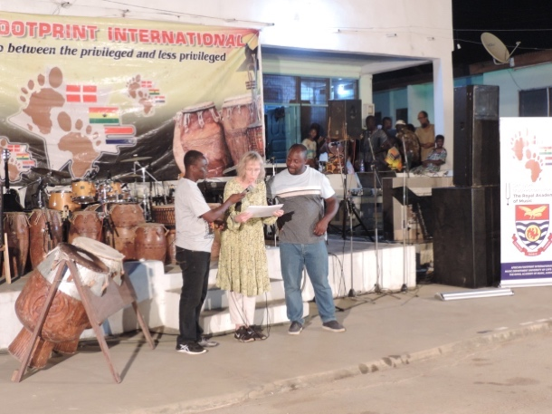 | 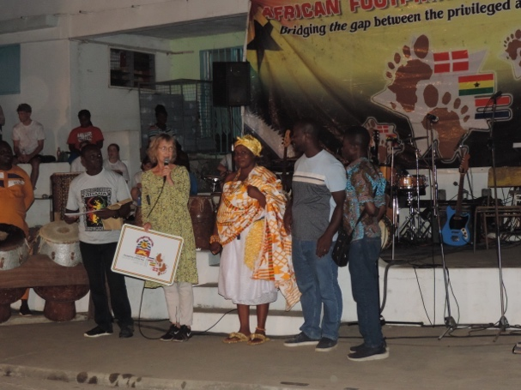
Certificate awards by Lene and Eric | Certificate to Partners by Footprint

JOINT CONCERT 2
After the wonderful concert by the RAMA and AFI, On the 11th January 2023, the University of Cape Coast, UCC also invited RAMA for yet another joint concert on the campus of the school. This allowed both the student of RAMA and UCC to have a full idea of how far this exchange program between, AFI, RAMA and the UCC would go.

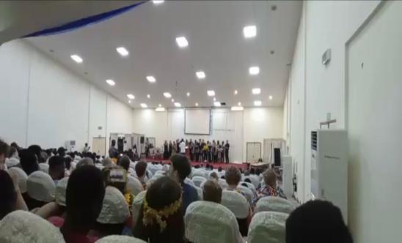 | 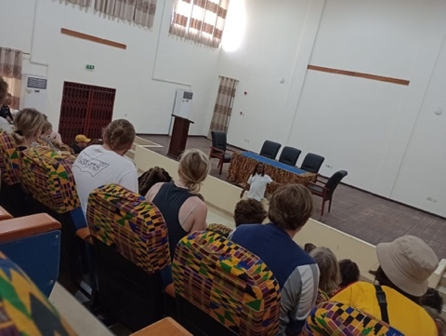
At the University of Cape Coast -Performance | At the University of Cape Coast

JOINT FOOTBALL MATCH
As the world has been united with football over the years, we also adopted the same culture – that, after every successful workshop and training for our student we therefore organize a football match between the teachers and the students. This was made and was successful.

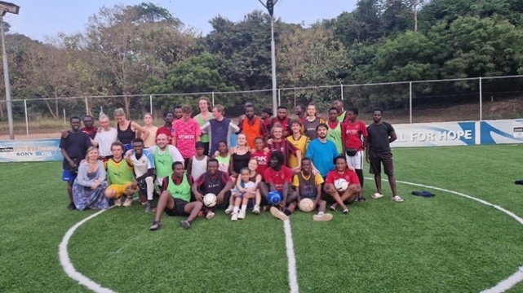 | 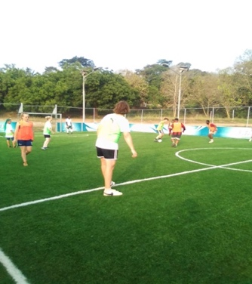
Joint entertainment – Football match | Football match – recreational time
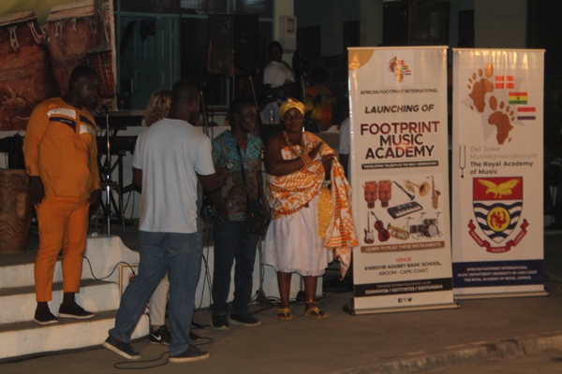 | 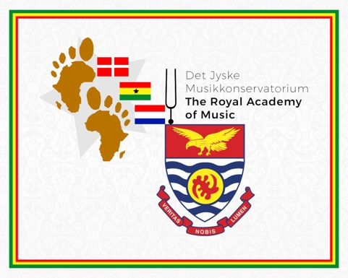
Launching of Footprint Music Academy | The 3 logo art certificate for the network
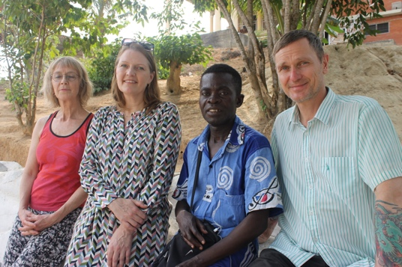 | 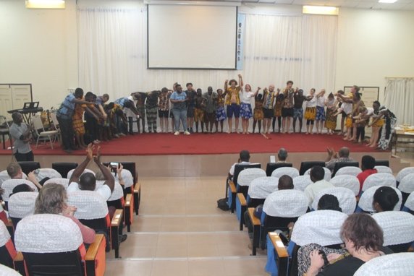
The Lead | End show – End

